

Department of Electronics and Computers
Study programme: Applied Electronics

Verification Project
Environmental Control Device

Table of Contents
1 The digital design of the circuit 4
1.1 Block Diagram 4
1.2 Description of the general functionality of the DUT (Device Under Test) 4
1.3 DUT Interfaces 5
1.4 List of DUT Functionalities 6
1.5 Waveforms 7
2 DIGITAL CIRCUIT VERIFICATION 8
2.1 Verification Environment Architecture 8
2.1.1 Sensor Agent 8
2.1.2 Sensor Transaction 9
2.1.3 Sensor Driver 9
2.1.4 Sensor Monitor 9
2.1.5 Sensor Coverage Collector 9
2.1.6 Sensor Sequences 9
2.1.7 Actuator Agent 10
2.1.8 Actuator Transaction 10
2.1.9 Actuator Monitor 10
2.1.10 Actuator Coverage Collector 10
2.1.11 Button Agent 10
2.1.12 Button Transaction 11
2.1.13 Button Driver 11
2.1.14 Button Monitor 11
2.1.15 Button Coverage Collector 11
2.1.16 Button Sequences 11
2.1.17 Scoreboard 11
2.1.18 Scoreboard Coverage Collector 12
2.2 Verification Checklist 12
2.2.1 Assertions 12
2.3 Functional Coverage Elements 13
2.4 Verification Scenarios and Tests 15
2.5 Results 16

The digital design of the circuit
Block Diagram
General Functionality Description of the DUT (Device Under Test)
DUT Interfaces
List of DUT Functionalities
Waveforms

Block Diagram

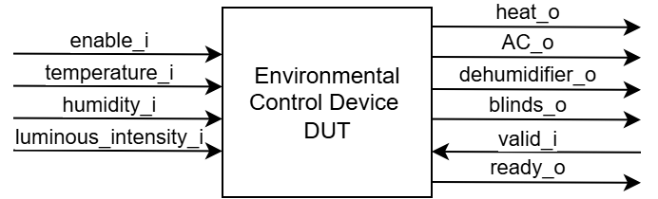
Figure 1. Block diagram of the device

Description of the general functionality of the DUT (Device Under Test)
The environmental controller receives temperature, humidity and light intensity measurements from sensors and controls heating, air conditioning, a dehumidifier and automatic blinds.
The button behaves as a toggle switch. When pressed, Enable becomes 1 and the controller starts operating. When pressed again, Enable becomes 0 and the controller is disabled.
Table 1. Sensor ranges
Sensor measurement | Min Value | Max Value
Temperature | 0 | 40
Humidity | 0 | 100
Light Intensity | 0 | 900

Based on the temperature sensor, the heating system turns on when the temperature drops below 22 degrees Celsius. The air conditioner turns on when the temperature exceeds 25 degrees Celsius and turns off when it reaches 22 degrees.
The values received from the humidity sensor control the dehumidifier. It turns on at a value exceeding 50% and turns off at values between 0% and 35%.
Depending on the light intensity levels, the curtains are opened or closed to limit the amount of light. The recommended light level in an office is 300–500 lux; thus, when the threshold of 700 lux is exceeded, the curtain closing system will activate, and at 200 lux, the curtains will open.
If the button is not pressed (enable=0) or the reset is active (reset_n = 1), all DUT outputs are set to 0. After the button is pressed again (enable = 1), the DUT outputs will be updated only after new data is read from the sensors.
Data received when the module’s enable signal is 0 is ignored (OFF state). Data is read only when enable, valid and ready signals are all asserted (load state). In the control state, various commands are executed based on the information received from the sensors.
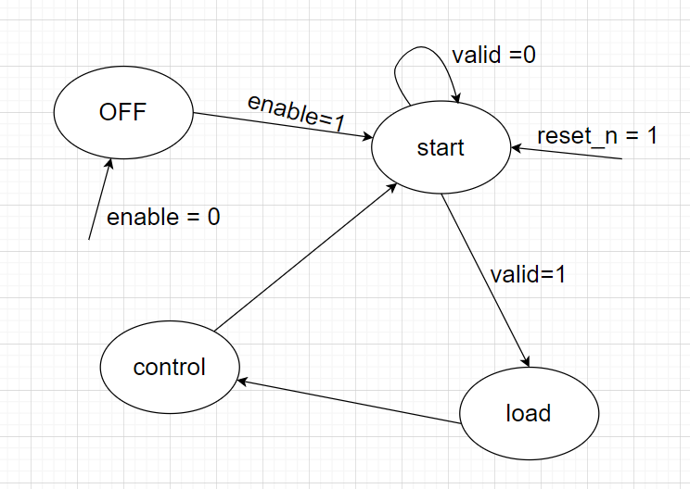
Figure 2. Finite State Machine describing the functionality of the device

DUT Interfaces
Table 2. System signals generated in the testbench
General Signals
Signal Name | I/O | Size | Description
clk_i | I | 1 | Clock signal
reset_i | I | 1 | Asynchronous reset, active high

Table 3. Button Interface
Button Interface
Signal Name | I/O | Size | Description
enable_i | I | 1 | For enabling/disabling device

Table 4. Sensor Interface
Sensor Interface
Signal Name | I/O | Size | Description
temperature_i | I | 6 | Temperature data
humidity_i | I | 7 | Humidity data
luminous_intensity_i | I | 10 | Luminous intensity data
valid_i | I | 1 | Valid signal
ready_o | O | 1 | Ready signal

Table 5. Actuator Interface
Actuator Interface
Signal Name | I/O | Size | Description
heat_o | O | 1 | Heating status
AC_o | O | 1 | AC status
dehumidifier_o | O | 1 | Dehumidifier status
blinds_o | 0 | 1 | Blinds status

List of DUT Functionalities
- Reads button state for enabling/disabling
- Receives environmental data from sensors
- Processes sensor data
- Enables/disables heat, AC, dehumidifier and blinds

Waveforms
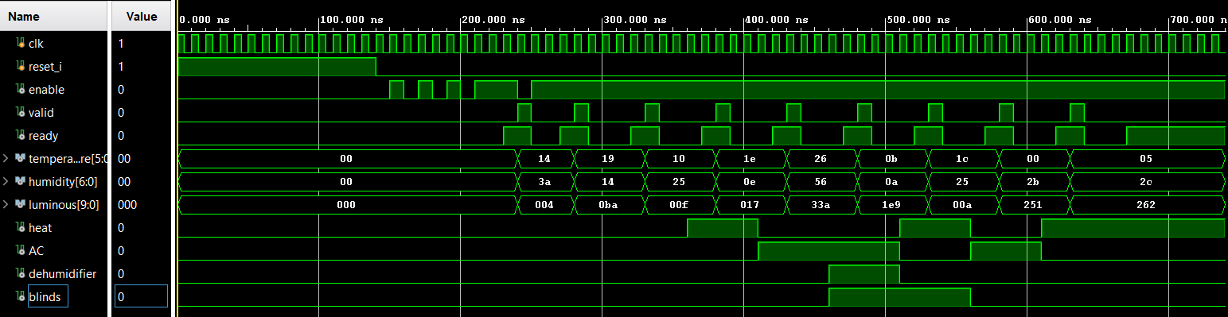
Figure 3. Waveforms from the DUT

DIGITAL CIRCUIT VERIFICATION
Verification Environment Architecture
Verification Checklist
Functional Coverage Elements
Verification Scenarios
Tests Results

Verification Environment Architecture
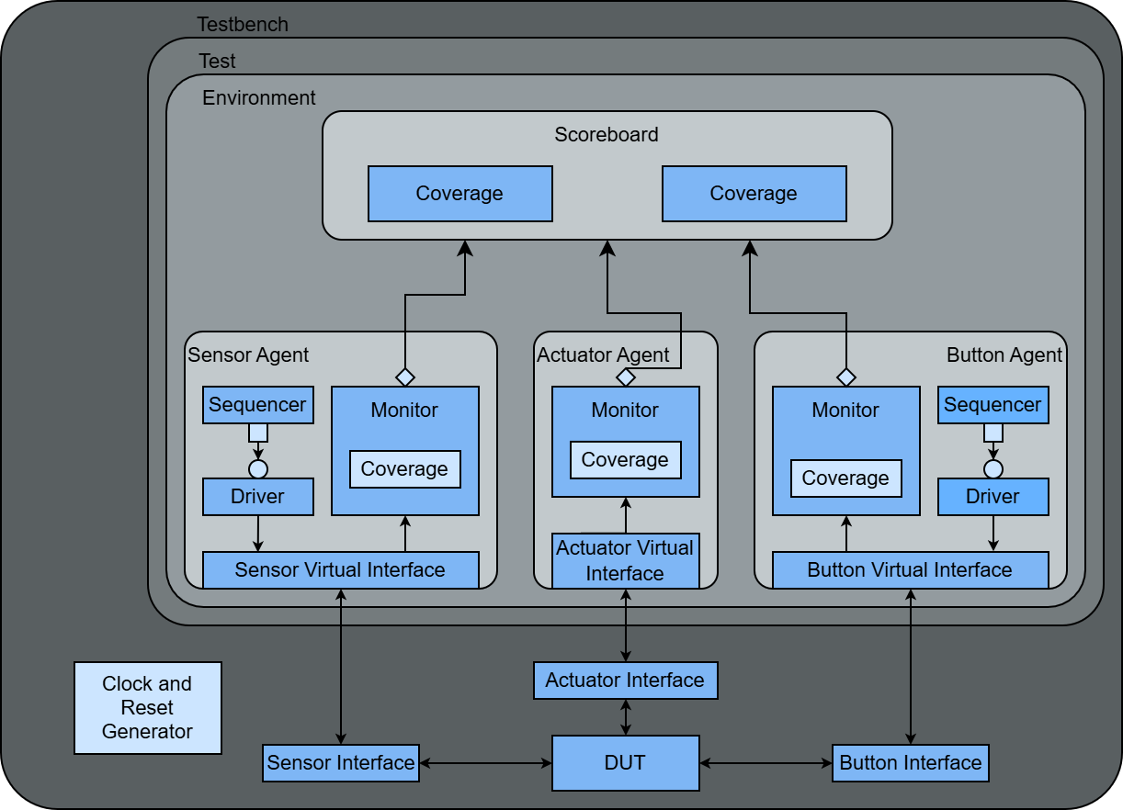
Figure 4. Overview of the components necessary for sending stimuli to the DUT

Sensor Agent
The Sensor Agent is an active agent that encapsulates the Sequencer, Driver and Monitor into a single entity, connecting the components with the DUT using the virtual interface.

Sensor Transaction
Table 6. Sensor Transaction
Field Name | Type | Size | Values | Description
temperature | rand bit | 6 | [0:40] | Value of environmental temperature
humidity | rand bit | 7 | [0:100] | Value of environmental humidity
luminous_intensity | rand bit | 10 | [0:900] | Value of environmental light intensity

Sensor Driver
The Sensor Driver interacts with the DUT via the Sensor Interface, sending the transactions generated by the Sensor Sequencer. The transactions follow the valid-ready protocol.
The driver receives transactions from the sequencer, waits for the ready signal to assert, asserts valid signal and drives sensors values, and after a clock cycle de-asserts the valid signal.

Sensor Monitor
The Sensor Monitor waits for valid and ready signals to be both asserted, samples the sensors values from the Sensor Virtual Interface, reconstructs the transaction and sends it to the Scoreboard and Sensor Coverage Collector.

Sensor Coverage Collector
The Sensor Coverage Collector is instantiated inside the Sensor Monitor and receives transactions from it. The coverage collector contains sensor_cg cover group with 4 cover points: temperature_cp, ac_cp, humidity_cp, luminous_intensity_cp.

Sensor Sequences
The Sensor Sequences generate stimulus for the Sensor Driver. Each sequence creates one or more constrained-random transactions that the driver sends to Sensor Interface. The following sequences are implemented:
Table 7. Sensor Sequences
Sequence | Description
temperature_sequence | Sends values of environmental temperature for every state of heat and AC.
humidity_sequence | Sends values of environmental humidity for every state of dehumidifier.
luminosity_sequence | Sends values of environmental light intensity for every state of blinds.
sensor_limit_values_sequence | Sends only lower and upper limits of every environmental data range.
random_sensor_sequence | Sends random values of environmental data.

Actuator Agent
The Actuator Agent is a passive agent that contains only the Monitor and connects it with the DUT using the virtual interface. The Actuator Interface has only output signals from DUT, meaning no driver or sequencer is needed.

Actuator Transaction
Table 8. Actuator Transaction
Field Name | Type | Size | Values | Description
Heat_i | rand bit | 1 | [0:1] | Heat command
AC_i | rand bit | 1 | [0:1] | AC command
Blinds_i | rand bit | 1 | [0:1] | Blinds command
Dehumidifier_i | rand bit | 1 | [0:1] | Dehumidifier command

Actuator Monitor
The Actuator Monitor samples the commands sent by DUT every time each of the values changes, reconstructs the transaction and sends it to the Scoreboard and Actuator Coverage Collector.

Actuator Coverage Collector
The Actuator Coverage Collector is instantiated inside the Actuator Monitor and receives transactions from it. The coverage collector contains actuator_cg cover group with 4 coverpoints: heat, ac, blinds, dehumidifier; and actuator_cross cross.

Button Agent
The Button Agent is an active agent that encapsulates the Sequencer, Driver and Monitor into a single entity, connecting the components with the DUT using the virtual interface.

Button Transaction
Table 9. Button Transaction
Field Name | Type | Size | Values | Description
enable | rand bit | 1 | [0:1] | Value of enable signal

Button Driver
The Button Driver receives transactions from the Button Sequencer and drives the enable signal.

Button Monitor
The Button Monitor waits for the enable signal to change, reconstructs the transaction and sends it to the Scoreboard and Button Coverage Collector.

Button Coverage Collector
The Button Coverage Collector is instantiated inside the Button Monitor and receives transactions from it. The coverage collector contains button_cg cover group with button_state cover point.

Button Sequences
The Button Sequences generate stimulus for the Button Driver. Each sequence creates one or more constrained-random transactions that the driver sends to Button Interface. The following sequences are implemented:

Table 10. Button Sequences
Sequence | Description
fast_switch_sequence | Alternative values for enable signal.
frequent_button_sequence | Device is mostly enabled.
rare_button_sequence | Device is mostly disabled.
button_sequence | Random values for enable signal.

Scoreboard
The Scoreboard receives transactions from all monitors.
When receiving a Button Transaction, the scoreboard stores the value of enable signal and predicts an implicit transaction from Sensor Monitor if enable is 0.
When receiving a Sensor Transaction, predicts the next Actuator Transaction if the stored enable signal value is 1.
All predicted Actuator Transactions are stored in a queue.
When receiving an Actuator Transaction, the scoreboard compares it with the predicted transaction, generating an error message if the checker fails.

Scoreboard Coverage Collector
The Scoreboard Coverage Collector is instantiated inside the Scoreboard and receives transactions from it. The coverage collector contains processed_data_cg cover group with 4 cover points: scbd_enable_cp, scbd_temperature_cp, scbd_humidity_cp, scbd_luminous_intensity_cp; and 3 crosses: temperature_cross, humidity_cross, luminous_intensity_cross.

Verification Checklist

Assertions
All Sensor assertions are disabled when reset is active to prevent false assertion failures.
Table 11. Actuator Interface Assertions
Assertion | Description
temperature_control | Verifies that heat and AC are not on at the same time.

Table 12. Sensor Interface Assertions
Assertion | Description
temperature_range | Verifies that temperature signal is in the interval [0,40].
humidity_range | Verifies that humidity signal is in the interval [0,100].
luminous_intensity_range | Verifies that luminous intensity signal is in the interval [0,900].

Functional Coverage Elements
Table 13. Actuator cover group
actuator_cg
Cover point | Values | Description
heat | [0:1] | Covers heat command
ac | [0:1] | Covers AC command
blinds | [0:1] | Covers blinds command
dehumidifier | [0:1] | Covers dehumidifier command
actuator_cross | heat x ac x blinds x dehumidifier | Covers all combinations of commands

Table 14. Sensor cover group
button_cg
Cover point | Values | Description
button_state | [0:1] | Covers device state

Table 15. Sensor cover group
sensor_cg
Cover point | Bins | Values | Description
temperature_cp | heat_on | [0:21] | Temperature for heat on
 | heat_limit_on | 22 | Temperature limit value for heat on
 | heat_limit_off | 23 | Temperature limit value for heat off
 | heat_off | [24:40] | Temperature for heat off
ac_cp | ac_off | [0:21] | Temperature for ac off
 | ac_limit_off | 22 | Temperature limit value for ac off
 | ac_stable | [23:24] | Temperature for ac stable
 | ac_limit_on | 25 | Temperature limit value for ac on
 | ac_on | [26:40] | Temperature for ac on
humidity_cp | dehumidifier_off | [0:34] | Humidity for dehumidifier off
 | dehumidifier_limit_off | 35 | Humidity limit value for dehumidifier off
 | dehumidifier_stable | [36:49] | Humidity value for dehumidifier stable
 | dehumidifier_limit_on | 50 | Humidity limit value for dehumidifier on
 | dehumidifier_on | [51:100] | Humidity for dehumidifier on
luminous  _intensity_cp | blinds_open | [0:199] | Luminous intensity for blinds open
 | blinds_limit_open | 200 | Luminous intensity limit value for blinds open
 | blins_stable | [201:699] | Luminous intensity for blinds stable
 | blinds_limit_close | 700 | Luminous intensity limit value for blinds closed
 | blinds_closed | [701:900] | Luminous intensity for blinds closed

Table 16. Scoreboard cover group
processed_data_cg
Cover point | Values | Description
scbd_enable_cp | [0:1] | Covers device state
scbd_temperature_cp | [0:40] | Covers temperature values
scbd_humidity_cp | [0:100] | Covers humidity values
scbd_luminous  _intensity_cp | [0:900] | Covers luminous intensity values
temperature_cross | scbd_enable_cp x scbd_temperature_cp | Covers temperature values when device is enabled
humidity_cross | scbd_enable_cp x scbd_humidity_cp | Covers humidity values when device is enabled
luminous_intensity  _cross | scbd_enable_cp x scbd_luminous_intensity_cp | Covers luminous intensity values when device is enabled

Verification Scenarios and Tests

Table 17. Verification Scenarios
Scenario | Description
Reset output values | Verifies that after a reset signal is applied, all DUT outputs are initialized to their expected default values.
Random Sensor Verification | Verifies the correct operation of the temperature, humidity, and light sensors using randomly generated input values.
Boundary Value Verification | Assign fixed boundary sensor values defined in the specification table.
Humidity Control Verification | Verifies that the humidity control logic operates correctly when humidity values remain within the normal operating range.
Light Intensity Control Verification | Verifies correct DUT behavior when light intensity values are within the recommended range.
Temperature Control Verification | Verifies the temperature control functionality when temperature values remain between 22 °C and 25 °C.
Enable Signal Functionality Verification | Verifies correct DUT operation when the enable signal is repeatedly toggled through multiple button presses.
Button Functionality Verification | Verifies the correct response of the DUT to rapid button presses and ensures proper button handling.
Periodic Shutdown Verification | Verifies that the environmental control module can be disabled and re-enabled during operation.

Table 18. List of implemented tests for DUT verification
Test file name | Test description
frequent_button_test | Test that DUT enables and disables correctly when button is pressed rapidly.
humidity_test | Test the DUT behavior for different humidity values from all operating ranges
luminosity_test | Test the DUT behavior for different luminosity values from all operating ranges
temperature_test | Test the DUT behavior for different temperature values from all operating ranges
sensor_limit_values_test | Test that DUT behaves correctly when sensor inputs are set to boundary values.
sensor_test | Test the correct operation of the environmental control system using randomly generated temperature, humidity, and light intensity values.

Results
Running the regression produced the following results:
- Sensor functional coverage: 100%
- Actuator functional coverage: 100%
- Button functional coverage: 100%
- Scoreboard coverage: 100%
All assertions passed without failures throughout the simulation

